*Term Project*

*Winter 2023*

*Instructor: Faisal Khan*

|  |  |  |
| --- | --- | --- |
| *Name* | *Student ID* | *Group#* |
| *Rupinder Kaur* | *C0849319* |  |
| *Burak Demir* | *C0853915* |  |
|  |  |  |
|  |  |  |
|  |  |  |

1-Use Documentation Comments where needed and use Javadoc to create HTML files for documentation.

2-In your project src folder add this word document with all your group members names and paste the screen shots of your output after each question.

2-Right Click on your Project Folder in Eclipse, Copy Option is available. Create a copy of the Project and upload the zipped folder using Moodle.

Create a web based application using Either JSF or JSPs & Servlets . Your web application should maintain

Bank Account Records. You can use a model class BankAccount

with fields like.

Account ID, Account Type(Checking/Saving), AccouHolderName,

AccountHolderContact, AccountBalance,AccountSetupDate.

You should be able to perform all these CRUD Operations.

**Solution: Model Class**

a)Create a Database BankAccounts for your application.

Create a table named Accounts in this database.

Insert 5 to 6 Records in this table. 10

**Solution:**

b) Display all the Bank Accounts in your xhtml page View or a JSP page as a table. 20

**Solution: - Code of jsp page for showing data in table format**

**Output:**

c) Add a new Bank Account in to the database using a button on your view page. 20

**Solution: - The button for it is “Insert Account Record”**

d)Update an existing Bank Account using an Update button on your view page. 20

**Solution: For updating the record the button is “Update”**

e)Delete a Bank Account using a Delete button on your view page. 20

**Solution: For deleting the account info the available button is “Delete”:**

f) Use ManagedBean if using JSF with annotation and create separate DAO class for Crud operations or use a Simple Java Bean as your Model class if using JSPs and Servlets.Try to create separate methods for all crud operations. 10

**Solution: Dao Class for all crud operations:**

**Method to set up connection with database:**

**Method to display the record of all accounts on jsp page:**

**Method to insert record into database:**

Method to delete record based on id:

Method to update record based on id:

Method for getting the info particular account:

Code of Controller:

Display record method:

Insert Method:

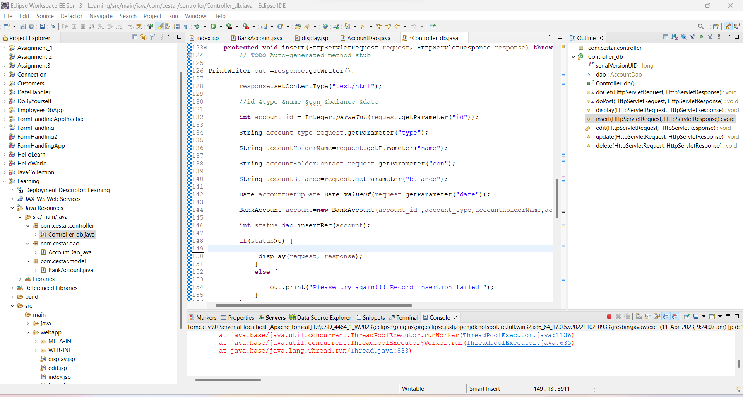

Edit method for getting the record and storing that in edit form:

Update method to update account info:

Delete method to delete the record of account:

**Index.jsp page** :

